MODULE 6

Planning and Learning

**The planning problem**- the task of coming up with a sequence of actions that will achieve a goal

Planning is required to reach a particular destination. It is necessary to find the best route in Planning, but the tasks to be done at a particular time and why they are done are also very important.That is why Planning is considered the logical side of acting. In other words, Planning is about deciding the tasks to be performed by the artificial intelligence system and the system's functioning under domain-independent conditions.

**Partial order planning**

* works on several subgoals independently
* solves them with sub plans
* combines the sub plans
* flexibility in ordering the sub plans
* A set of actions that make up the steps of the plan

**total order planning**

* Forward/backward state-space searches are examples of totally ordered plan search explore
* only strictly linear sequences of actions directly connected to the start or goal
* They only explore linear sequences of actions from start to goal state. They cannot take advantage of problem decomposition, i.e. splitting the problem into smaller sub-problems and solving them individually.

**Learning in AI**

An agent is learning if it improves its performance on future tasks after making observations about the world.

Learning Agent

[**Supervised Learning**](https://www.javatpoint.com/supervised-machine-learning)**-**

In supervised learning, models are trained using labeled dataset, where the model learns about each type of data. Once the training process is completed, the model is tested on the basis of test data , and then it predicts the output.

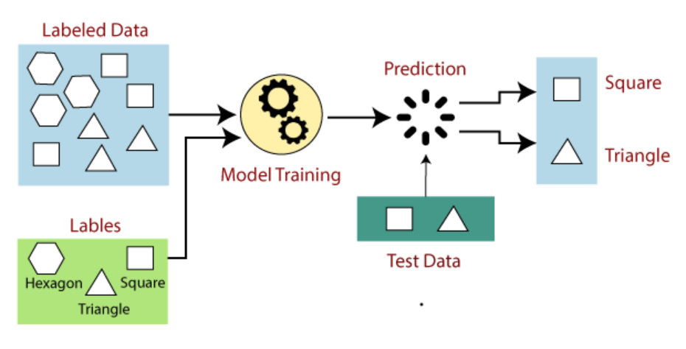

[**Unsupervised Learning**](https://www.javatpoint.com/unsupervised-machine-learning)**-**

Unsupervised learning is a machine learning technique in which models are not supervised using training dataset. Instead, models itself find the hidden patterns and insights from the given data. It can be compared to learning which takes place in the human brain while learning new things

Unsupervised learning is a type of machine learning in which models are trained using an unlabeled dataset and are allowed to act on that data without any supervision.

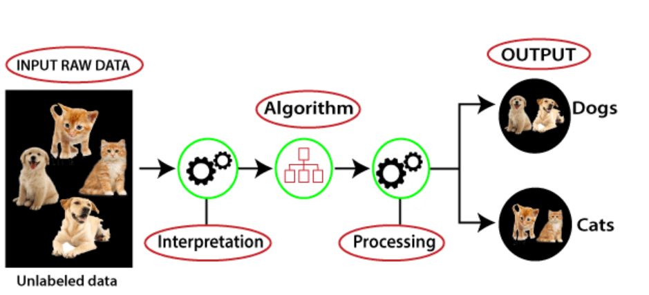

[**Semi-Supervised Learning**](https://www.javatpoint.com/semi-supervised-learning) **-**

Semi-Supervised learning is a type of Machine Learning algorithm that represents the intermediate ground between Supervised and Unsupervised learning algorithms. It uses the combination of labeled and unlabeled data sets during the training period. Although Semi-supervised learning is the middle ground between supervised and unsupervised learning and operates on the data that consists of a few labels, it mostly consists of unlabeled data. As labels are costly, but for the corporate purpose, it may have few labels.

**Reinforcement Learning-**

* Reinforcement Learning is a feedback-based Machine learning technique in which an agent learns to behave in an environment by performing the actions and seeing the results of actions. For each good action, the agent gets positive feedback, and for each bad action, the agent gets negative feedback or penalty.
* In Reinforcement Learning, the agent learns automatically using feedback without any labeled data, unlike [supervised learning.](https://www.javatpoint.com/supervised-machine-learning)
* Since there is no labeled data, the agent is bound to learn by its experience only.
* RL solves a specific type of problem where decision making is sequential, and the goal is long-term, such as game-playing, robotics, etc.
* The agent interacts with the environment and explores it by itself. The primary goal of an agent in reinforcement learning is to improve the performance by getting the maximum positive rewards.
* 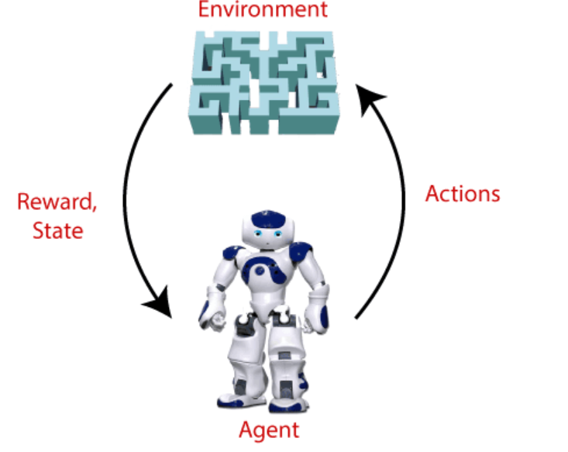
* **Agent():** An entity that can perceive/explore the environment and act upon it.
* **Environment():** A situation in which an agent is present or surrounded by. In RL, we assume the stochastic environment, which means it is random in nature.
* **Action():** Actions are the moves taken by an agent within the environment.
* **State():** State is a situation returned by the environment after each action taken by the agent.
* **Reward():** A feedback returned to the agent from the environment to evaluate the action of the agent.
* **Policy():** Policy is a strategy applied by the agent for the next action based on the current state.
* **Value():** It is expected long-term returns with the discount factor and opposite to the short-term reward.
* **Q-value():** It is mostly similar to the value, but it takes one additional parameter as a current action (a).

**Ensemble Learning.**

Ensemble methods combine different decision trees to deliver better predictive results, afterward utilizing a single decision tree. The primary principle behind the ensemble model is that a group of weak learners come together to form an active learner.

**Expert Systems**

An expert system is a computer program that is designed to solve complex problems and to provide decision-making ability like a human expert. It performs this by extracting knowledge from its knowledge base using the reasoning and inference rules according to the user queries.An Expert system is a domain in which Artificial Intelligence stimulates the behavior and judgment of a human or an organization containing experts. It acquires relevant knowledge from its knowledge base and interprets it as per the user’s problem. The data in the knowledge base is essentially added by humans who are experts in a particular domain. However, the software is used by non-experts to gain information. It is used in various medical diagnoses, accounting, coding, gaming, and more areas.

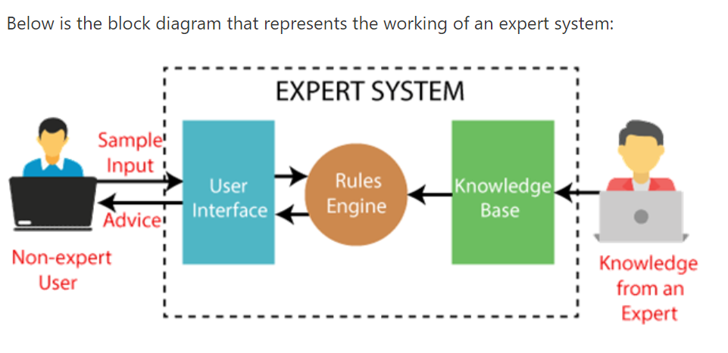

[Components of Expert System:](https://www.javatpoint.com/expert-systems-in-artificial-intelligence)

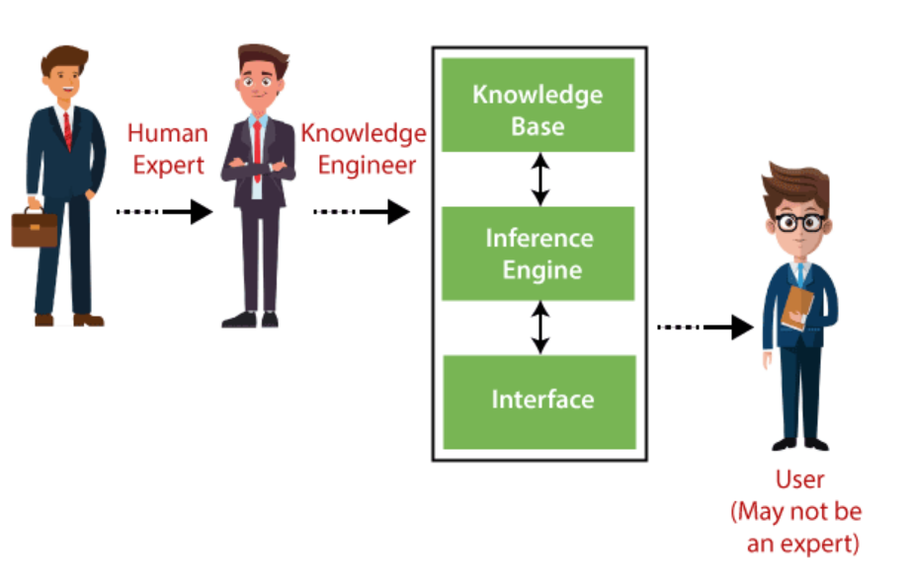

* Knowledge base

The knowledgebase is a type of storage that stores knowledge acquired from the different experts of the particular domain. It is considered as a big storage of knowledge. The more the knowledge base, the more precise will be the Expert System.It is similar to a database that contains information and rules of a particular domain or subject.

* Inference engine

The inference engine is known as the brain of the expert system as it is the main processing unit of the system. It applies inference rules to the knowledge base to derive a conclusion or deduce new information. It helps in deriving an error-free solution of queries asked by the user.With the help of an inference engine, the system extracts the knowledge from the knowledge base

* user interface

With the help of a user interface, the expert system interacts with the user, takes queries as an input in a readable format, and passes it to the inference engine. After getting the response from the inference engine, it displays the output to the user. In other words, it is an interface that helps a non-expert user to communicate with the expert system to find a solutionThis component is essential for a non-expert user to interact with the expert system and find solutions.

working memory

**Development of Expert Systems**

* Firstly, ES should be fed with expert knowledge. In the case of MYCIN, human experts specialized in the medical field of bacterial infection, provide information about the causes, symptoms, and other knowledge in that domain.
* The KB of the MYCIN is updated successfully. In order to test it, the doctor provides a new problem to it. The problem is to identify the presence of the bacteria by inputting the details of a patient, including the symptoms, current condition, and medical history.
* The ES will need a questionnaire to be filled by the patient to know the general information about the patient, such as gender, age, etc.
* Now the system has collected all the information, so it will find the solution for the problem by applying if-then rules using the inference engine and using the facts stored within the KB.
* In the end, it will provide a response to the patient by using the user interface.